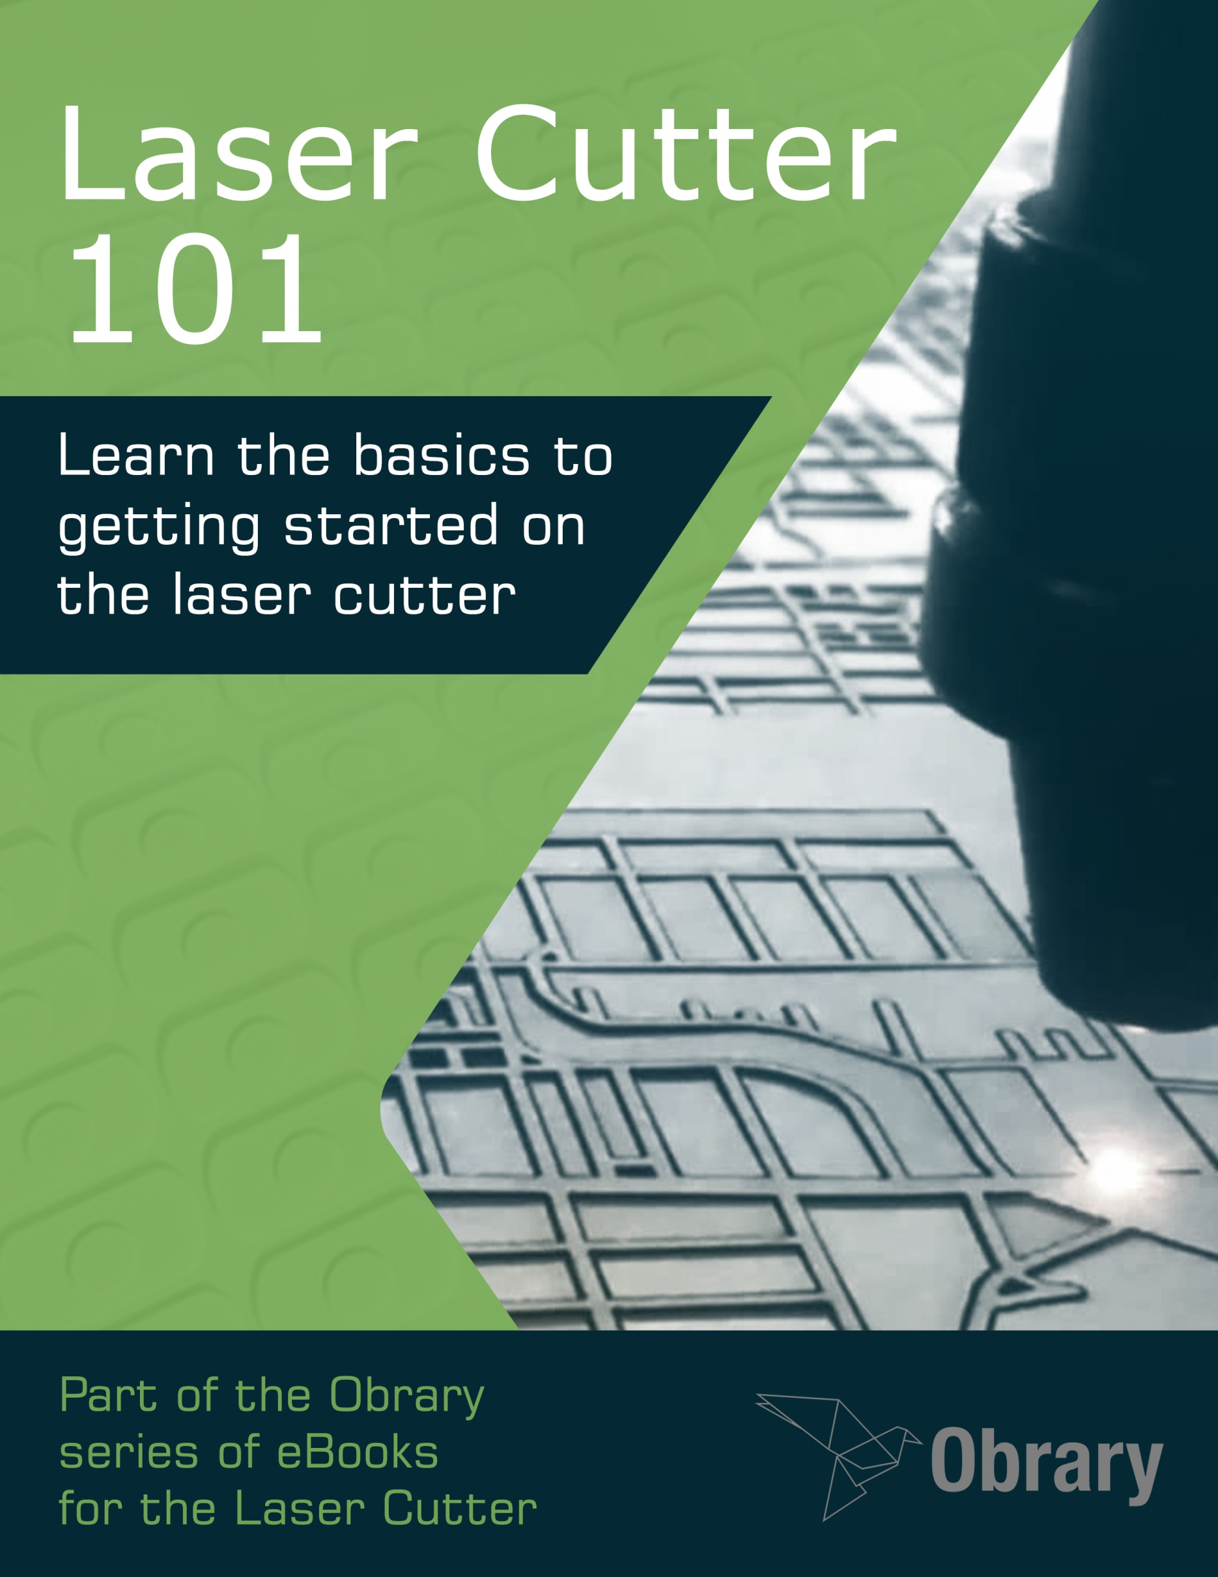

Contents

Laser Cutter Overview 1

Choosing a CO2 Laser Cutter 8

Materials to Cut on the Laser Cutter 13

Tools to Bring to the Laser 24

First Projects for the Laser Cutter 29

About Obrary 34

## Version

This document was last updated September 30, 2015.

## License

This eBook is distributed under the Creative Commons BY-SA license.



# Laser Cutter Overview

Laser cutting is a technology that uses a laser to cut and engrave materials In the past, it has typically used for industrial manufacturing applications because of the high cost of the machines. Currently, the cost for the machinery is coming down, so they are starting to be used by schools, small businesses, and hobbyists.

Laser cutting works by directing the output of a high-power laser through optics. The laser optics and CNC (computer numerical control) are used to direct the laser beam. A typical commercial laser for cutting materials involves a motion control system to follow a CNC or G-code of the pattern to be cut and/or engraved onto the material. The focused laser beam is directed at the material, which then either melts, burns, vaporizes away, or is blown away by a jet of gas leaving an edge with a high-quality surface finish.

## What do Lasers Do?

Here are the three general tasks that lasers perform:

**Cutting** – this is when the laser cuts all of the way through the material creating separate pieces

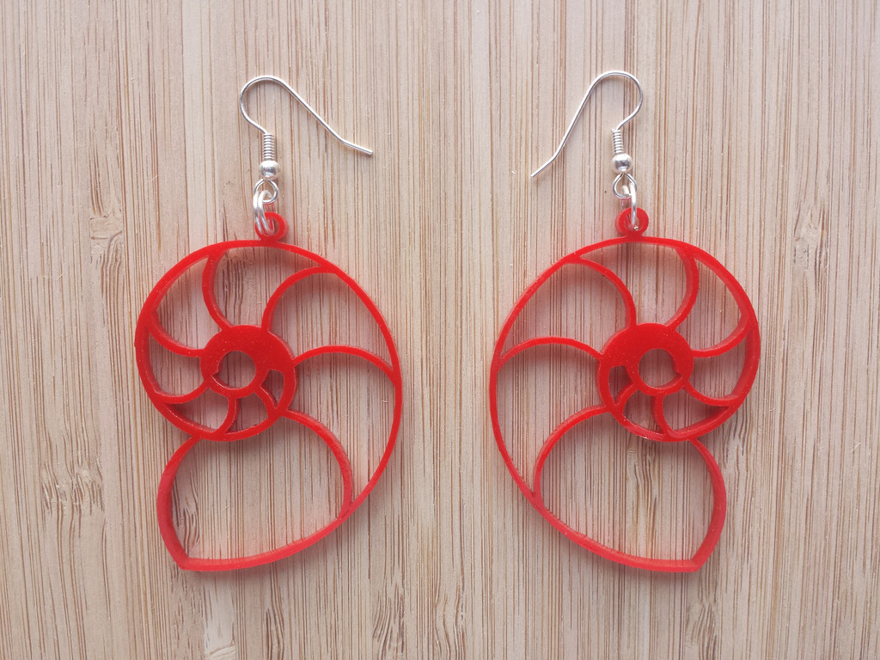

Laser Cutting  
Product design - <http://obrary.com/products/earrings-nautilus>

**Engraving** – engraving is when the laser does not cut all of the way through the materials. I bit of the top material is removed over an area leaving a pocket

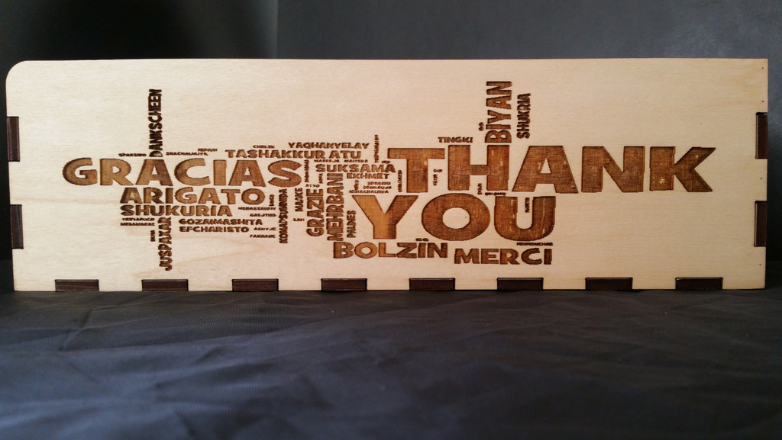

Laser Engraving  
Product Design - <http://obrary.com/products/wine-gift-box>

**Marking** – this is when the laser does not remove material. Marking can change the color of the material or change the properties of a coating applied to the material.

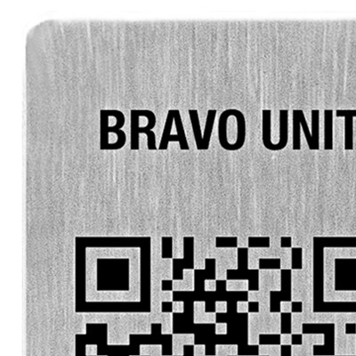

Laser Marking

## Laser Design

There are two popular types of laser systems, flatbed and galvanometer.

### Flatbed Laser

The flatbed laser is the more commonly used laser in the maker world and small businesses. It has a laser tube that generates the laser beam. The beam is then transmitted to the material by a series of mirrors that are installed on a machine controlled gantry system. The gantry allows the beam at X/Y coordinate of the laser bed.

Flatbed lasers can come in enclosed systems that keep the lasering within an enclosed box for ventilation and light control. Larger flatbeds though can be in open systems where ventilation and light need to be controlled at the room level.

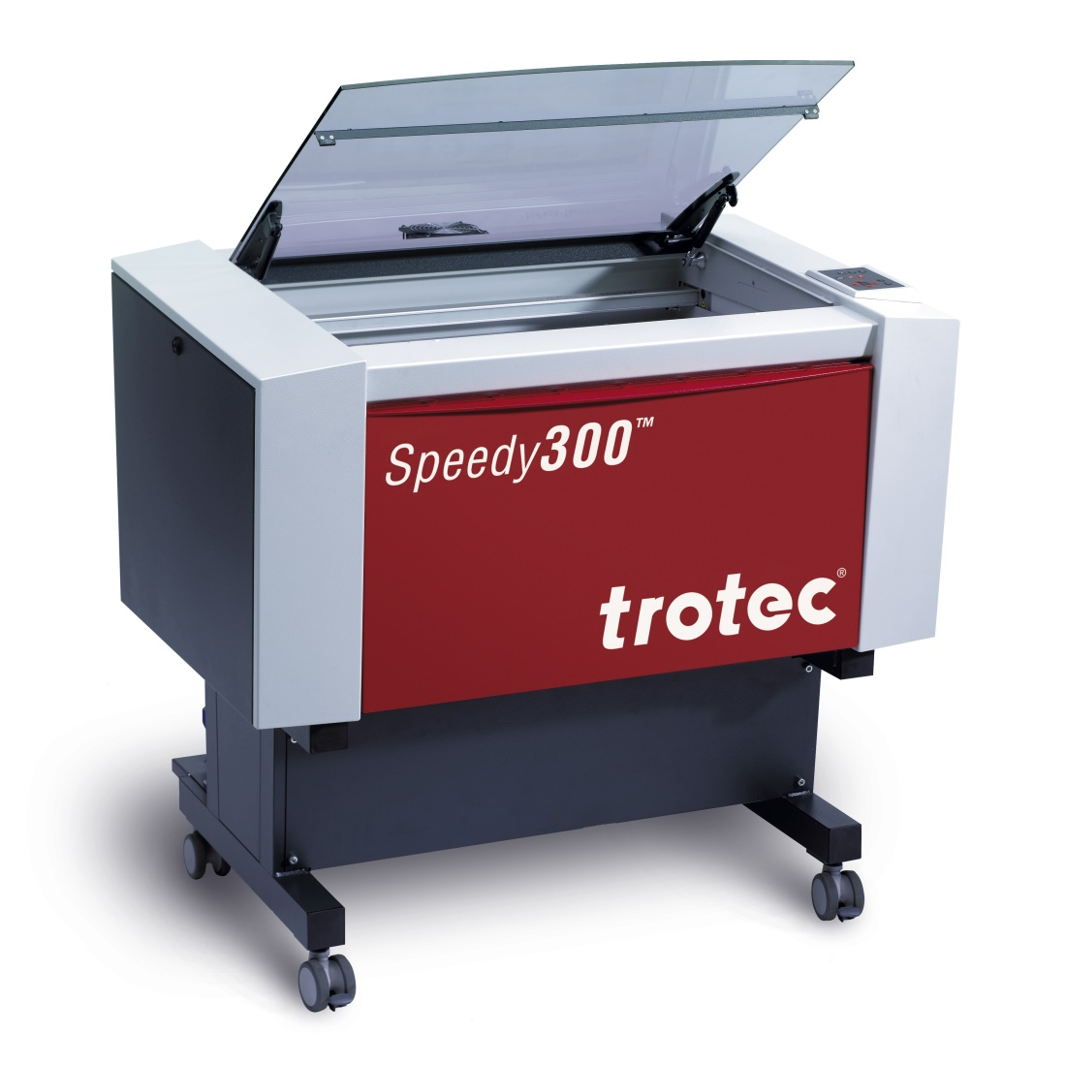

Enclosed Flatbed Laser Cutter

### Galvanometer Laser

A Galvanometer Laser is typically used in industrial situations. The laser beam is delivered by two mirrors instead of a gantry system. This allows the galvanometer laser to be ten times faster than a flatbed laser, but it also has a smaller working area.

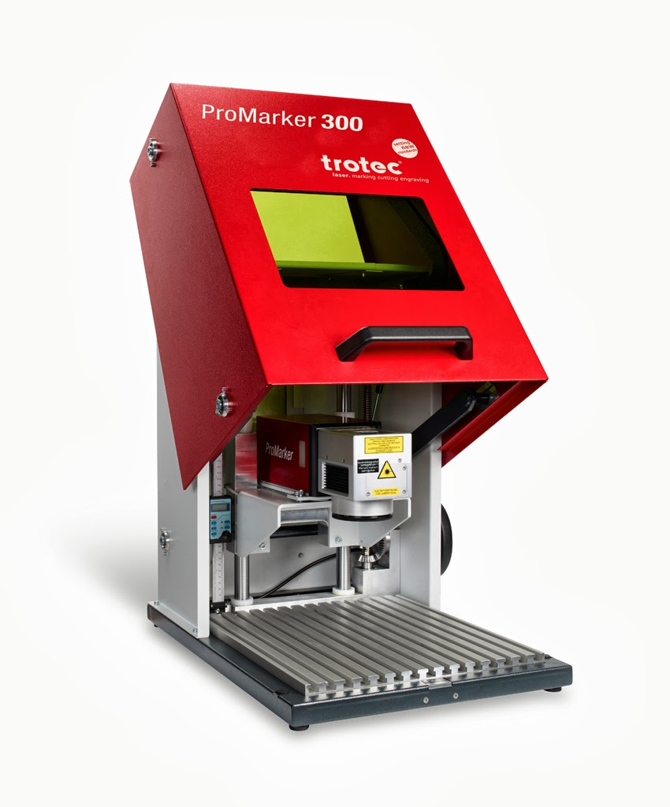

Galvanometer Laser

## Types of Lasers

There are two main types of lasers, CO2 and Fiber. They are based on different technologies and have significant differences in their capabilities.

### CO2 Lasers

CO2 lasers have been around for decades. With a CO2 laser, the beam is created in CO2 filled tube. The wavelength of CO2 lasers is between 9.4 and 10.6 micrometers. Generally, CO2 lasers are not good for metals. They are good at cutting carbon based materials. Here’s a table showing the capabilities of a CO2 laser on different types of material:

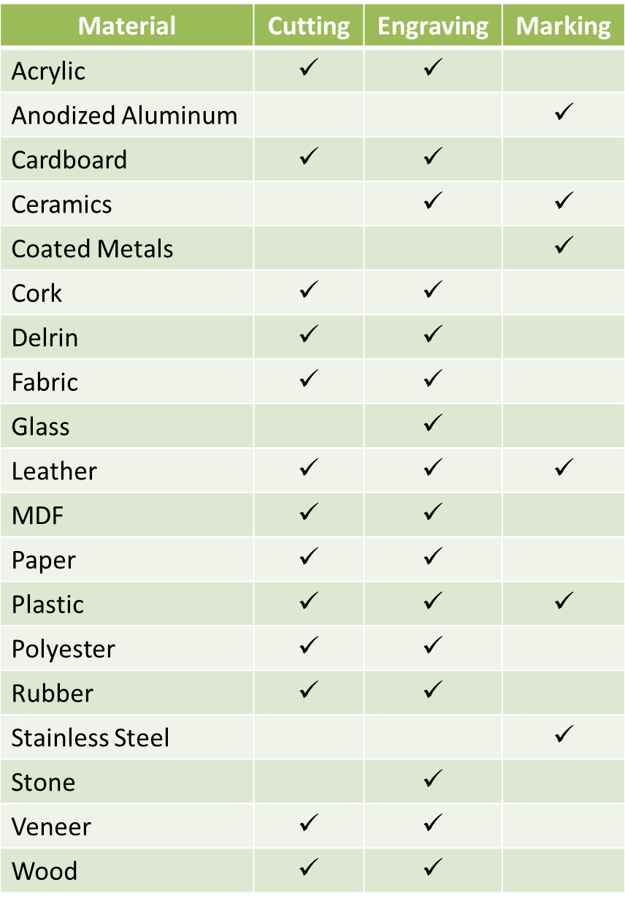

CO2 Laser Capabilities

## Fiber Lasers

Fiber Lasers are a newer development in the world of lasers. The beam is created in an optical fiber doped in the rare-earth element Ytterbium. Fiber lasers are also called YAG lasers. The YAG stands for Yttrium Aluminum Garnet.

The wavelength of the beam from a Fiber laser is 1.06 micrometers. This is one tenth of the wavelength of CO2 lasers. Therefore, the laser beams behave very differently. The beam diameter on Fiber is smaller than that on a CO2 resulting in finer detail in the work.

Here’s a breakdown of a Fiber laser’s capabilities across different materials:

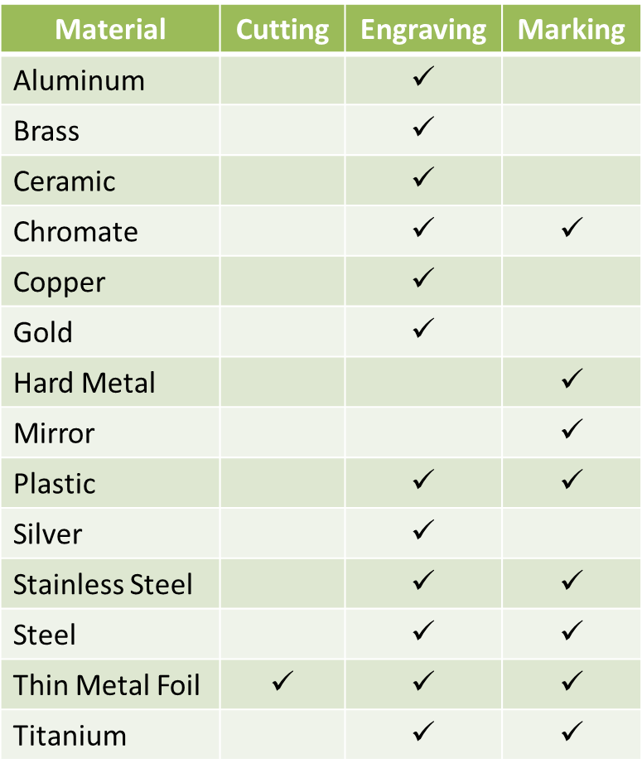

Fiber Laser Capabilities

# Choosing a CO2 Laser Cutter

A laser cutter is a fantastic tool. It can cut and engrave all kinds of materials. And, if you've decided to add one to your set of tools, here's some information to help you through the decision making process.

The focus here is on CO2 lasers, which are the more common and widely used type of lasers. The other type of laser is Fiber, which creates laser of much higher power. It is used to cut metal and in industrial settings. So the machines are an order of magnitude more expensive.

Even in the realm of CO2 lasers, there is a wide variety in choice of laser cutters. And the selection is continuously growing. As such, specific brands or models won’t be discussed. What follows is a walkthrough of the factors to consider and decisions to make during the selection process.

## Should You Buy a Laser Cutter Now?

Of course, we all want our very own laser cutter. But is ownership the right choice for you at this time? There are other options to having your own laser cutter.

One option to consider is getting access to local shared laser. This could be at a FabLab, Hacker Space, Maker Space, library or community college. Many of these places provide access to a laser and other tools on a monthly subscription fee or pay by the hour.

### Benefits of a shared laser

* Here’s one of, the biggest benefits of a shared machine. Not only do you get access to the tools, but you get access to like-minded people. These people can help you learn new tips and tricks.
* You don't have to spend the large initial capital investment.
* You don't need to maintain the machine.
* The shared laser may have more capabilities/power than you can afford in a machine of your own.

### Downside of a shared laser

* You need to share the machine. That may require reserving it ahead of time or only being able to book it a limited number of times per week.
* Shared equipment general gets more abuse, so be prepared for more issues with the machine.
* Access is usually not 24x7.
* You may have to cut a project short when your reservation time is expired.

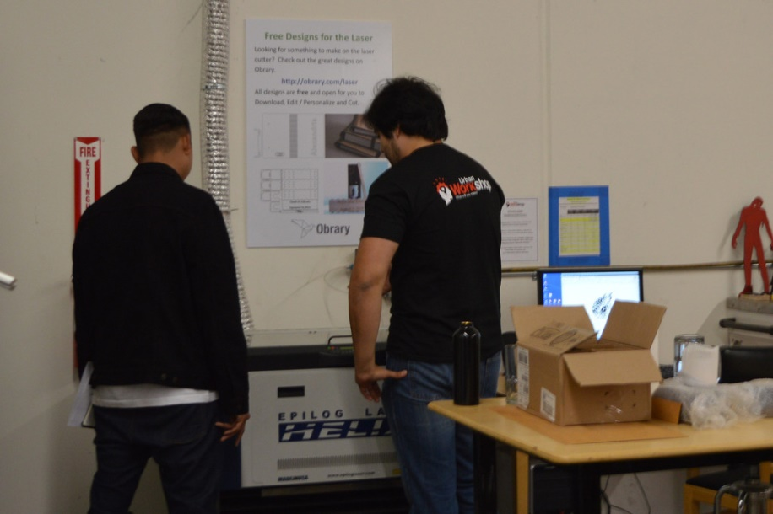

**The shared laser at Urban Workshop in California**

## Determine Your Needs

Before you start looking at laser cutters, you should be clear about what you are going to use the laser for.

### Type of material

Lasers can be used on a wide variety of materials. You can learn more about those materials in another section of this eBook. The type of material that you will be using affects your choice of lasers. You'll need a much more powerful laser for wood than you would for cardboard.

### Size of material

The size of the raw material that you will be putting into the laser will affect the size of the bed that you need. That said, if you buy 1/4" plywood in 4'x8' sheets, you don’t have to have a 4'x8' laser. You can cut the sheets into thirds so they fit into a 3'x4' laser.

Also the height of your material is important. For example, if you want to engrave bricks, you'll need to fit those bricks under your laser.

### Size of finished product

Your laser is going to need a bed that is bigger than the final size of the products.

### Cutting, engraving or both

The type of work you will be doing on the laser will have an impact on the power that you need. So for each material that you'll be using, decide if you will be cutting and/or engraving it.

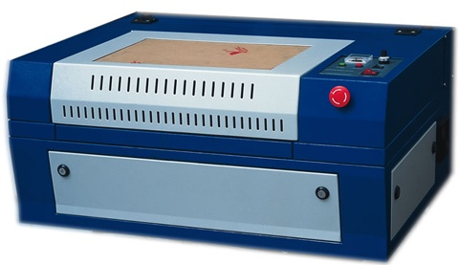

**Desktop Laser Cutter**

## Factors of a Laser Cutter to Consider

There are number of factors to consider when selecting a laser cutter. Unless your funds are unlimited, you'll need to make some trade-offs between these. The following is a list a factors to consider with the more important criteria at the top of this list and less important at the bottom.

### Price

The purchase price of laser cutters varies widely based on all of the variations of the criteria discussed in this section. There are entry level lasers available for under $1,000. And the biggest, most powerful and highest quality laser cutters quickly exceed $100,000. Your budget will probably be the biggest deciding factor on which laser you buy.

### Power

Power refers to the power output of the laser. The more powerful the laser, denser the material it can cut and engrave. And more power also means that work can be done more quickly. CO2 lasers go up to 180 watts. Here's a guide on what capabilities are available at different powers:

|  |  |
| --- | --- |
| **Power** | **Use Cases** |
| Under 40 Watts | Primarily used for engraving. |
| 40-60 Watts | Allows for deeper engraving at a higher speed engraving. And you can cut thin materials. |
| 60-100 Watts | Deep engraving and cutting of common materials for laser cutting. |
| 100 Watts or More | Cutting of thicker material is possible and in fewer passes. |

### Quality

Quality in machines across product lines and manufacturers vary greatly. A poorer quality machine will require more frequent maintenance and repair.

One of the big drivers in quality (and price) is the type of tube that the laser uses. Tubes come in glass, metal and ceramic. Here’s a comparison of them:

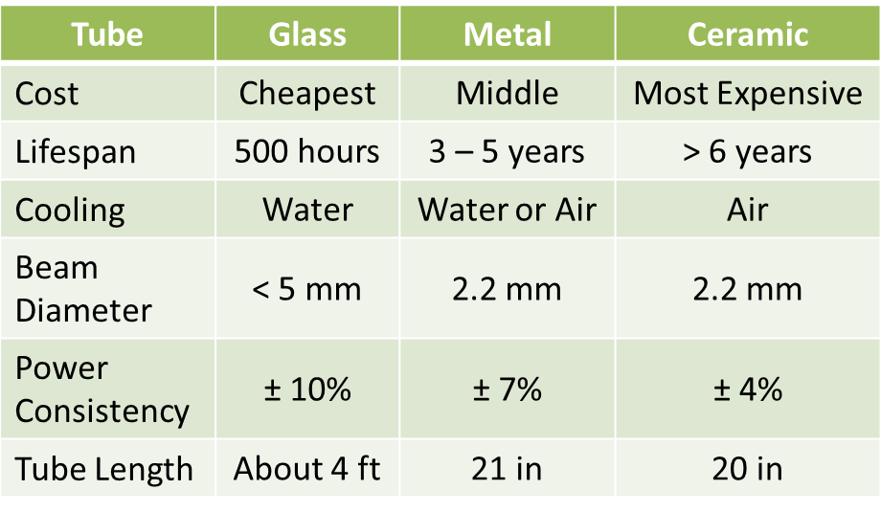

Comparison of CO2 Laser Tube Types

### Bed size

The bed size is the maximum X-Y dimensions of material that can be placed in the laser. A larger bed size allows the cutting of a higher quantity of parts in a single run and also allows cutting of larger parts.

### Z-axis

The bed of a laser is adjustable in the z-axis to accommodate different thicknesses of material. So, if you want to engrave bricks, you'll need to ensure the laser's bed moves low enough in the Z direction to fit the brick under the laser at the right focus distance.

### Accessories

Some lasers come with accessories that increase its functionality. For example, a rotary tool is used when engraving round objects like bottles. So if you want to engrave round objects, you'll need to select a laser cutter that allows for rotary tools.

### Maintenance

Laser cutters do require regular maintenance. Make sure that you have the skill needed to perform the required maintenance and can commit to doing it on schedule.

### Cooling and ventilation

Some laser cutters require dedicated cooling and/or ventilation systems. These systems add complexity to the installation and maintenance of the machine. Also, the machine may come bundled with these systems or they may be additional purchases.

### Speed

Speed refers to how fast the lens is moved in the X and Y direction over the material. The higher the speed of the machine, the more quickly it can complete projects.

### Software Requirements

The software requirements of machines vary. Some use a printer driver to have a computer communicate with the machine while others have dedicated CAM software that you will have to learn how to use. Some only work on Windows. Some software only works in metric units.

### Floor Space Consumed

Laser cutters can take up a lot of space. First you have the machine itself. Then you may also have cooling equipment, ventilation equipment and a dedicated computer to control it. You need to factor in all of these things when determining if you have adequate space for the laser cuter.

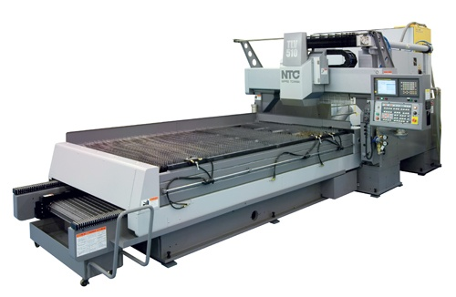

**Large bed laser cutter**

## Other Resources

Here’s the [2014 Laser Engraving Buyer’s Guide](http://www.engraversjournal.com/3dissue/dr3054/) from Engravers Journal.

# Materials to Cut on the Laser Cutter

Laser cutters provide a fine level of control over cutting and engraving of a wide variety of materials. Here is a guide to the different materials you can use with a laser. The benefits and drawbacks of each material are described. And you will learn where to source the material.

## Acrylic

Acrylic is a type of plastic that is a common material used on the laser cutter. The term acrylic is used for products that contain a substance derived from acrylic acid or a related compound. Most often, it is used to describe a clear, glass-like plastic known as poly(methyl) methacrylate (PMMA). PMMA is also called acrylic glass. For the laser, acyrlic is extruded into sheets of various thickness, color and transparency.

### Pros

* Available in a wide variety of colors and thickness
* Light weight
* Sheets come laminated with pealable paper that protects it during the lasering process
* No post processing needed

### Cons

* Relatively expensive
* Brittle
* Easily scratched

### Where to find it

You can get sheets of acrylic at your local plastics store. Just search for 'acrylic supplier' to find a store near you. If you live in an area that doesn't have a supplier nearby, you can order it online.

Acrylic comes in sheets. Most supplies will cut the sheet down for you if you want less than a full sheet.

Here's one way to save money. If your local supplier cuts sheets to order, they also have scrap material. They probably sell the scraps at significant cost savings. The scraps are sold by the pound. Here, scraps means parts of sheets. They are decent sized from one square foot to a full quarter of 4'x8' sheet. As they are scraps, not all colors and thickness are always available. So you may want to stop by your local supplier regularly to see if they have any scarce colors in the bin.

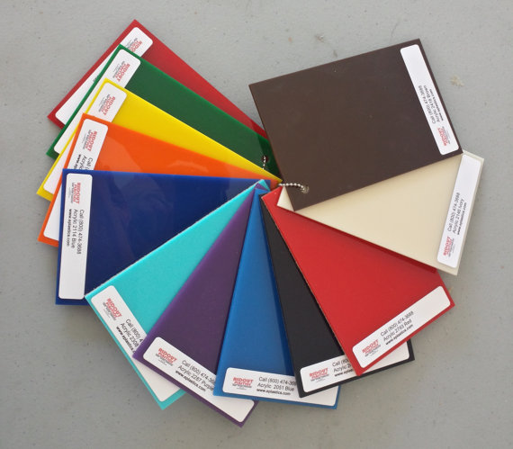

**Acrylic is available in a spectrum of colors**

## Wood

Wood is a very common material on the laser cutter. Some people are surprised that wood can be cut on the laser as they expect it to go up in flames. While wood can catch on fire from the laser, it easy to ensure that it does not. The laser needs to blow air on the cutting area. This helps to remove heat from the wood so that it doesn't ignite.

Wood can be both cut and etched on the laser. Plywood and board stock can both be used.

### Pros

* Relatively cheap
* Readily available

### Cons

* Cutting the wood burns the edges. Some people do not like this look
* The organic nature of wood provides imperfections that may affect the final result
* Heavy post-processing (sanding, staining, etc) to get a 'finished' look

### Where to find it

Many plywoods can be found at your local Big Box retailer. Lowe’s stocks a 1/4" maple in 4'x8' sheets that is great for the laser. For higher quality hardwoods, search out your local hardwood lumber shop.

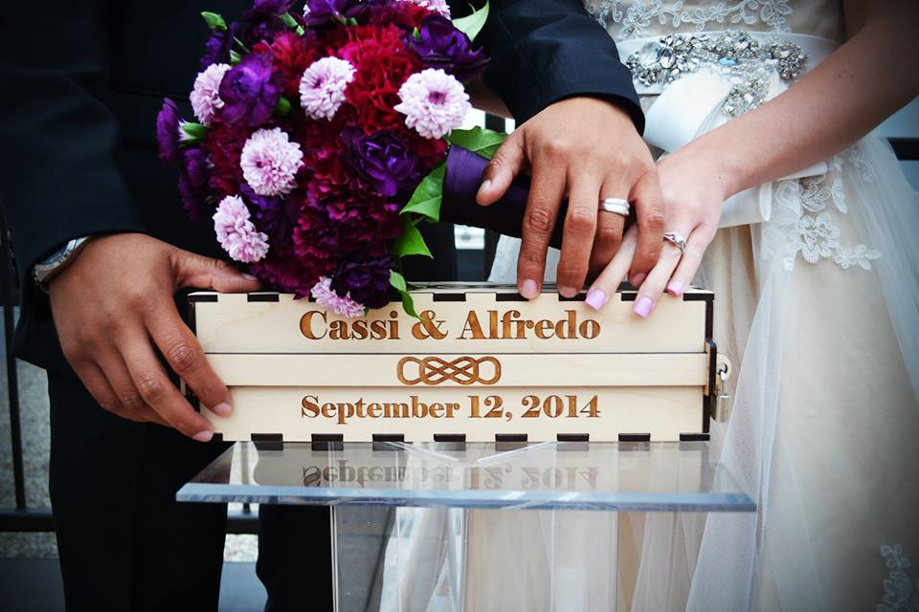

Laser cut and engraved 1/4" maple plywood  
Product design - <http://obrary.com/products/wedding-ceremony-wine-box>

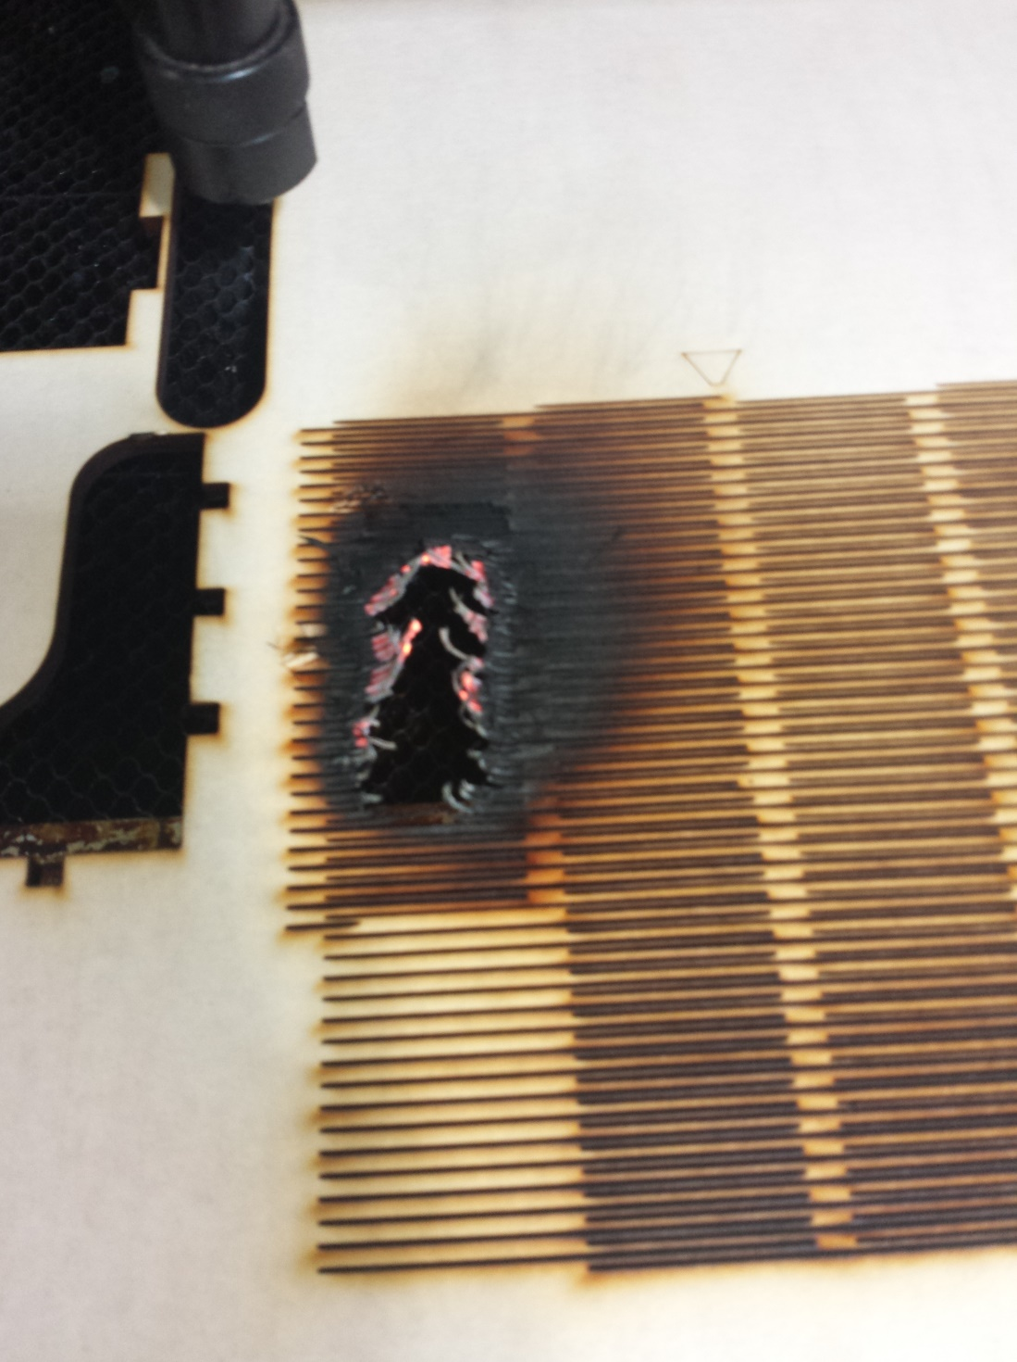

**Plywood burned by the laser**

## Bamboo

Bamboo is technically a grass, not a wood. So it gets its own section here. Like wood it is available in plywood sheets. Common sizes are 1/4" and 1/8" thick sheets. It is denser than most 1/4"wood plywoods.

### Pros

* Beautiful look with multiple grain options
* Finish doesn't need as much sanding as wood
* Eco-friendly material
* Strong, dense material

### Cons

* Cutting the bamboo leaves a charred edge that will need to be wiped clean or sanded.
* Relatively expensive

### Where to find

The 1/4" plywood sheets are typical found at your local quality hardwood store (in other words, not at the local big box retailer. The 1/8" plywood is harder to find. You can get it online and have shipped to you. You can have them cut the 4'x8' sheets into thirds to save money on the shipping.



**Folding notepad covers in 1/8” Bamboo  
Product design -** [**http://obrary.com/products/folding-notepad-booklet**](http://obrary.com/products/folding-notepad-booklet)

## MDF

MDF is a great product for the laser. Because it is manufactured, it is a more consistent material than wood. So its performance under the laser is more predictable. MDF cuts well. Engraving it yields a more 'fuzzy' result.

### Pros

* Relatively inexpensive
* Consistent material resulting in predictable cuts

### Cons

* Doesn't engrave well

### Where to find it

MDF is readily available at your local big box store.



**Laser cut MDF**

## Metal

Anodized Aluminum - can be etched (Black anodized aluminum provides best contrast out of all anodized aluminum)

Brass - un-coated brass cannot be etched with a laser as it is too reflective. It needs to have some kind of coating like paint.

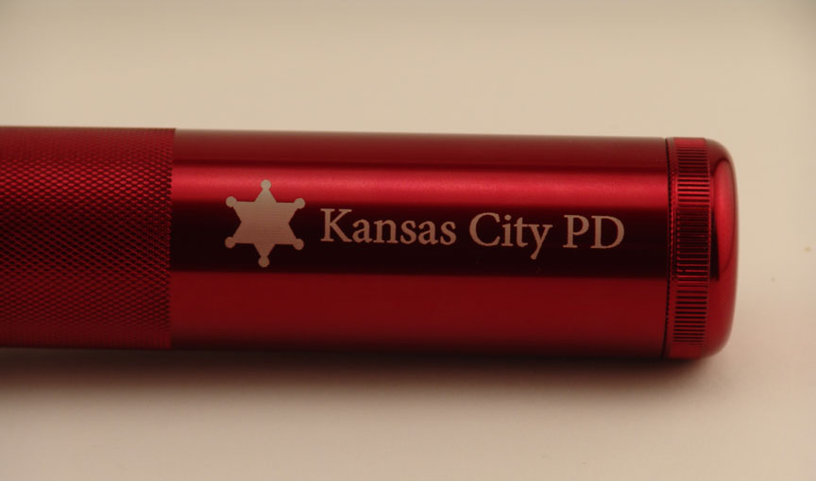

**Laser engraved anodized aluminum**

## Glass

Glass can be etched on the laser with some beautiful results. This includes bottles (both full and empty), drinking glasses, and plain flat glass.



**Engraved glass bottles**

## Stone

Yes, you can engrave different types of stone with a laser cutter. Stone is generally too hard to cut through with a CO2 laser though. Here are some details:

### Rocks

Rock is a hard material. Some will engrave better than others. To have a consistent engraving, you'll want to start with rocks that are smooth. River rock is a good place to start.

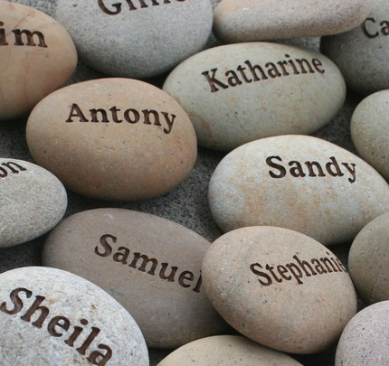

**Laser engraved river rocks**

### Marble

Marble engraves very well. It’s very hard so you'll need to go slow with the laser at full power. Here's an example of black marble. The engraving is naturally white, so the contrast between engraving and background is very large.

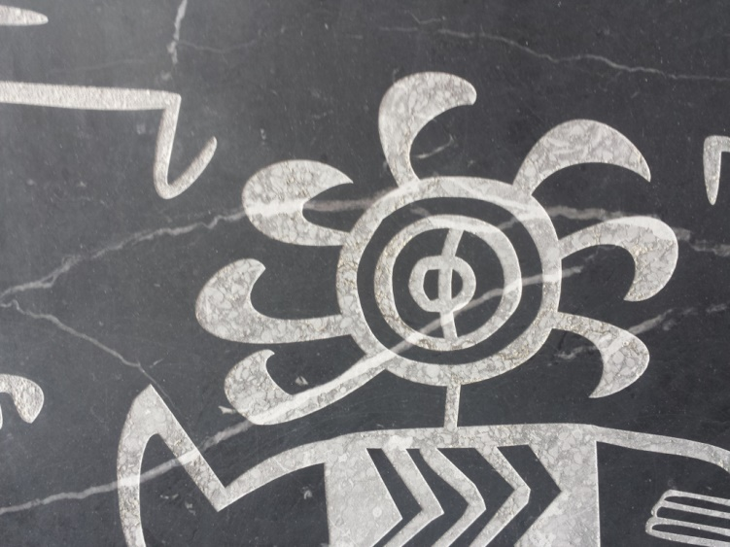

**Laser engraved black marble**

### Granite

Granite does engrave, but it doesn't engrave as well as marble. The reason for this is that granite is not a consistent material. It's made up of a variety of minerals. This variation becomes a variation in hardness. So engraved granite is not a smooth as other materials. And as you can in this photo, the color of the engraving is also inconsistent.

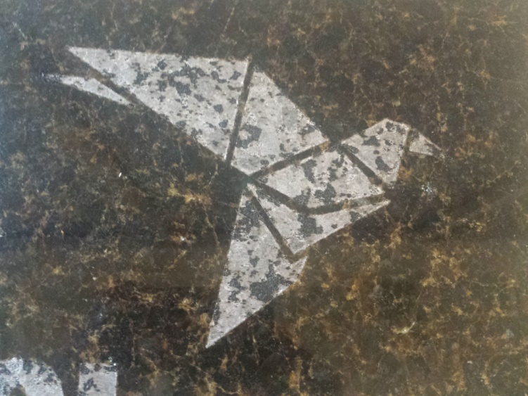

**Laser engraved granite**

## Other Materials

Lots of materials can be either cut or engraved in the laser. If there's something you want to try, go ahead and experiment with it. Here are some other materials that can be used on the laser:

* Whiteboard
* Cardstock
* Paper
* Fabric

## Products

One fun thing to with a laser is to engrave products. This can include cell phone cases, laptops, bottles and much more. As long as the surface you are engraving is a laserable material, you are good to go.

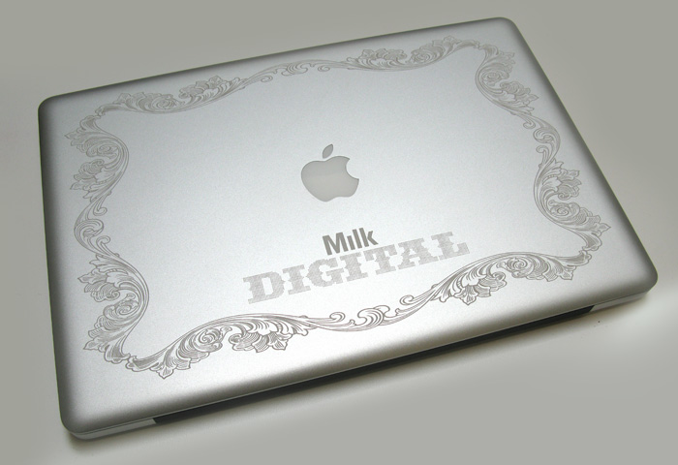

**Laser engraved MacBook Pro**

## Materials to Avoid

PVC and vinyl are not safe for the laser. Lasering these materials produces a corrosive chlorine gas that is toxic and can also damage your laser.

# Tools to Bring to the Laser

When you are working on the laser cutter, you should have some tools with you to handle whatever situations happen. Here's a recommendation of tools that you can bring with you to the laser cutter.

|  |  |
| --- | --- |
| Tool Box Having a bag to keep all of your tools is handy. Just grab the bag and you’ll have all the needed tools. Home Depot has a wide variety of heavy duty canvas bags, so you'll be able to find the right sized one for all of the things you carry. | laser-cutter-tool-bag |
| Application Tape Application tape is used to protect materials from laser charring. Some materials, like acrylic, come with protective paper applied to the surface. But other materials like wood do not. That's where the application tape comes into play. Application tape is not very sticky, like painter's tape. But it comes in much wider rolls. You can get it in a variety of widths for 12" to 36". You can find application tape at your local sign shop supply store. | application-tape |
| Blue Painter's Tape This is regular painter's tape that you can get at any hardware store. This tape is used in a couple of ways.   * The first use is to protect the surface of smaller pieces being cut. Much in the same way as application tape. * The second use is for making squares to place material down on. This technique is explained further in the eBook described at the bottom of this page. | blue-tape |
| Cardboard Cardboard is used to make jigs as explained elsewhere in this eBook. And you can use it to do a test cut with before cutting more expensive material. | cardboard |
| Calipers Calipers are used to measure the thickness of materials. You will use that information to determine the right speed and power settings for the laser.  These calipers are digital and display both inches and metric. These calipers are available at Harbor Freight and are relatively inexpensive at under $20. | digital-calipers |
| Utility Knife A razor blade is useful for cutting tape and cardboard. It also good for cutting material that wasn't cut all of the way through by the laser cutter. | folding-utility-knife |
| Scissors A simple pair of heavy duty tape for cutting cardboard, application tape, blue tape and material. | sciccors |
| Sharpie A sharpie is useful for marking material, tape and jigs. | sharpie |
| Tape Measure A tape measure is quite useful. One use it to measure material to see if it is large enough for the pieces you want to cut. Get one with both inches and metric scales on it. | tape-measure |
| Hacksaw Blade Carry a hacksaw blade, but not the hacksaw frame. You can use it to cut material where the laser cutting was incomplete. | hacksaw-blade |

# First Projects for the Laser Cutter

Here we have a collection of basic designs that you can make using the laser cutter. Making these will give you the basic skills needed for the use of the laser cutter.

## Project 1 - Earbud Holder

The earbud holder is a great first project to make. Its a one piece product, so no assembly is required. The picture shows the earbud holder cut from 1/8" bamboo.

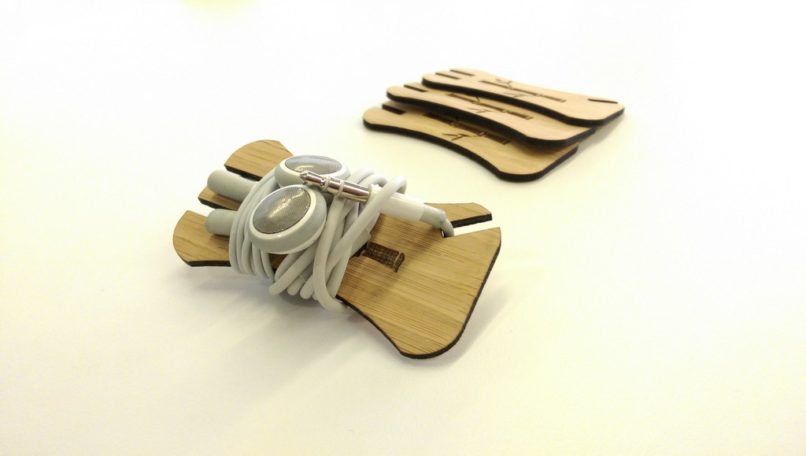

**Earbud Holder  
See design at** [**http://obrary.com/products/earbud-holder**](http://obrary.com/products/earbud-holder)

### Material

Use plywood, MDF or acrylic

## Project 2 - Magazine Box

This box is sized to hold magazines or owner's manuals. It uses finger joints which is common joinery for laser projects to allow for easy alignment of the pieces. It can be assembled with small nails or glue. The picture shows it made in 1/4" maple plywood.

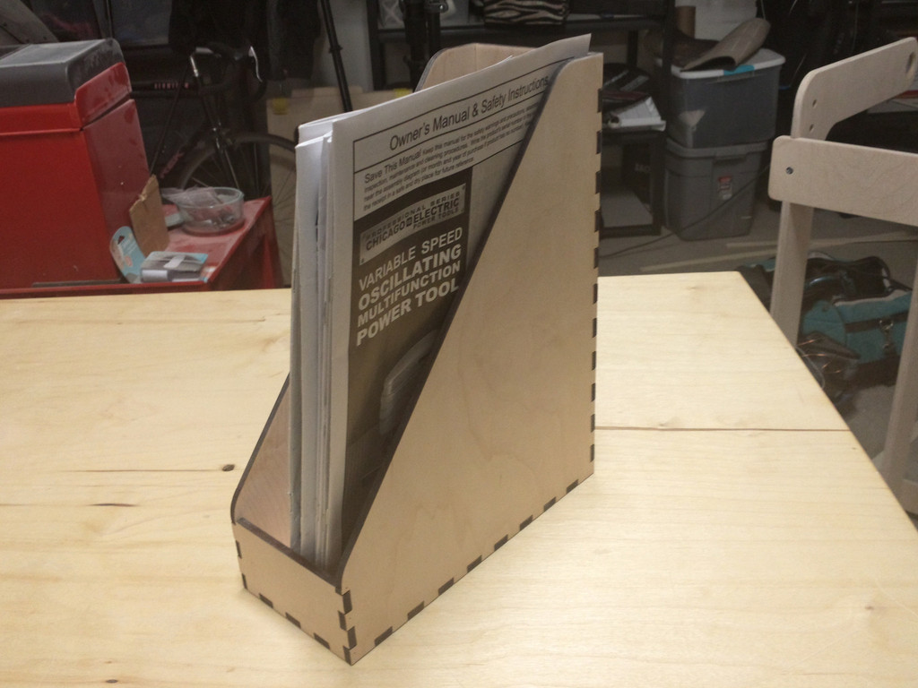

**Magazine Box**  
**See the design at** [**http://obrary.com/products/magazine-box**](http://obrary.com/products/magazine-box)

### Material

Use plywood or MDF

## Project 3 - Finger Box

For your first project, you should make a finger box. Fingers is a common joinery for laser projects. The box design can be scaled up or down to make bigger or smaller boxes. One thing to note is that the length of the fingers should be equal to the thickness of the material being used. The picture shows it made in 1/4" maple plywood.

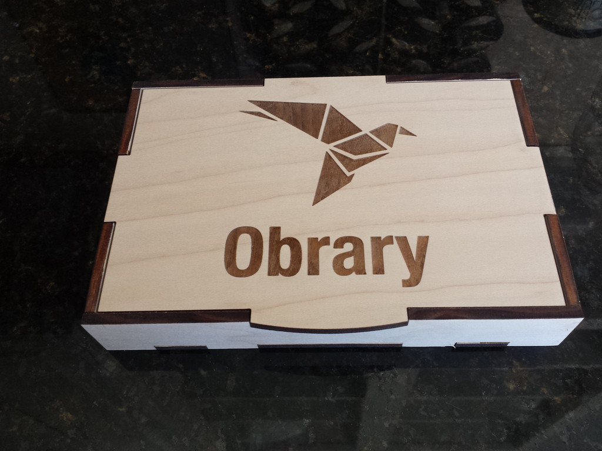

**Finger Box  
See the desgn at http://obrary.com/products/finger-box**

### Material

The finger box can be made from plywood, MDF or acrylic.

## Project 4 - Cage Ball

This is a somewhat useless product. But its great to get you thinking about how flat sheets of material can be turned into 3D spheres. The picture shows it made in 3mm MDF and 3mm red acrylic.

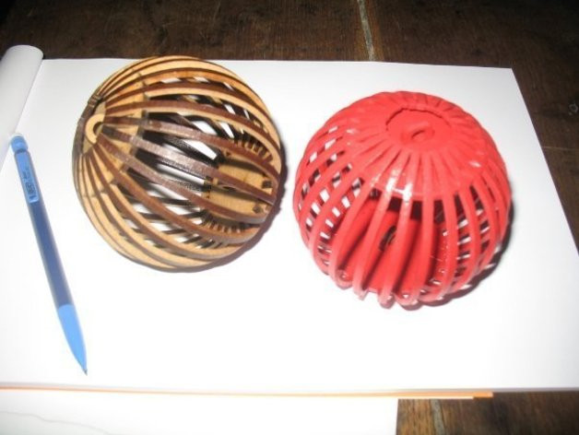

**Cage Ball  
See the design at** [**http://obrary.com/products/cage-ball**](http://obrary.com/products/cage-ball)

### Material

The Cage Ball can be made from wood, MDF or acrylic.

## Project 5 - Triceratops

Here's another example of using material that comes in sheets and turning it into a 3D object. The picture shows it made in 1/4" orange acrylic.

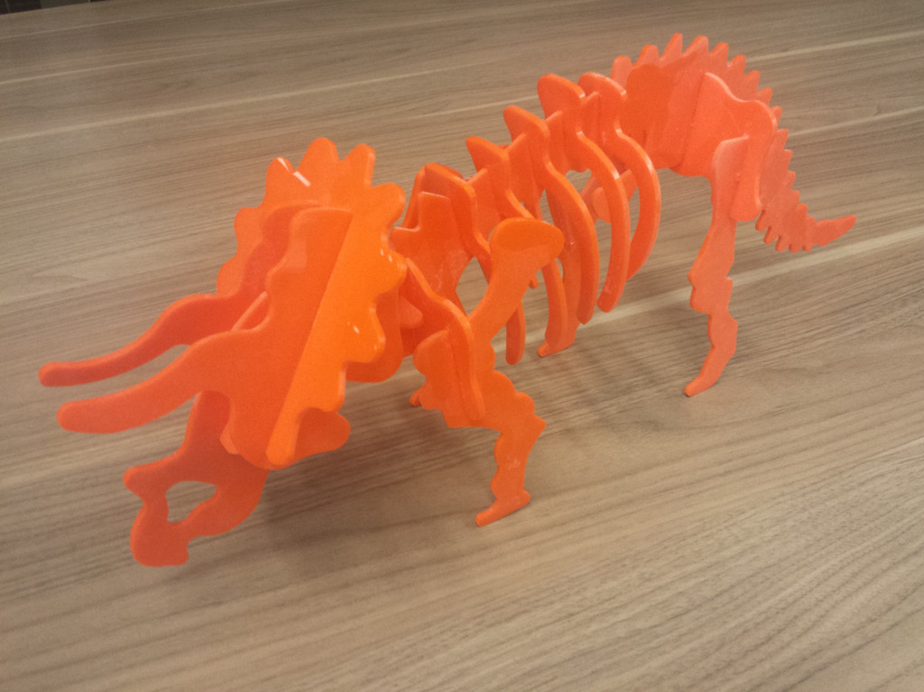

**Triceratops  
Found at** [**http://obrary.com/products/triceratops**](http://obrary.com/products/triceratops)

### Material

The Triceratops can be made from wood, MDF, acrylic or cardboard.

# About Obrary

Obrary is a technology company based in San Diego, California. Obrary is focused on software that automates the digital manufacturing process.

You can visit Obrary on the web at <http://obrary.com>.

## Free, Open Designs

Obrary provides a free library of open designs for products that are made on the laser cutter. See the products at <http://obrary.com/laser>.

## Community Support

Get your laser questions answered by the community at <http://forums.obrary.com/category/fabrication-tools/laser-cutter>.

